Clockwise Confusion at Rocky as the Cuckoo Calls Cause Chaos in the Castle Bog
from Leitrim Lodge by the Anti-Clockwise Hotelier
“Many’s a cartload of turf was drawn from the Castle Bog at Leitrim Lodge by horse, mule, donkey and machine to keep the home fires burning in the stern winters of old”.
Many globally logoed adorned feet descended on the Castle Bog at Leitrim Lodge on Thursday past to compete in race number five of the 2023 Hill and Dale Series. New meets old indeed, as a race record of 268 runners lined up to trod again among the turf drawn silent ghosts of days long past.
This race is formally known as Rocky but in addition to scaling Rocky competitors have to take on the summits of Tornamrock (the Badgers Tower), Pierces Castle and Altataggart (the Hill of the Priest). The 2022 race saw it run in an anti-clockwise sequence, therefore for 2023 it reverted to clockwise with the unforgiven and rugged 405metre mountain face of Rocky having to be confronted first.
Race director the older McVeigh (aka one job Gerard) pre-race managed to cause extreme chaos to all attending runners with his lack of understanding by what clockwise and anti-clockwise actually means. The Oxford Learners Dictionary defines clockwise as “corresponding to the way in which the hands of a clock move round". The older McVeigh in his wisdom and his downright lack of common sense decided pre-race to send out numerous social media posts and website updates that the race would be in an anti-clockwise direction, which resulted in 268 people repeatedly asking the registration team what direction the race actually was going. While the registration team headed by Bogusboy were polite to the first few requests it soon became frustrating and a grunt of Rocky first was the only description given to anyone who dared to ask.
Registration opens and the best dressed award goes to?
By 6pm the South Down Clonduff/Cabra townland of Leitrim, also known locally as the grey ridge, started to become inundated by a diverse mix of runners and interested onlookers from all parts of Northern Ireland. Registration initially became a battle of the brothers as the McVeigh race directors Connaire and Brian (aka the chuckle brothers) became under some intense pressure from the Rodgers brothers, Podge and Rodge, about who was going to undertake what roles. A sense of calmness prevailed with the arrival of the Jammie Dodger eating Bogusboy and his able assistant Miss World who were both extremely well dressed and looked more like they were standing for local council election rather than coming to roll their slieves up and help assist with a mountain running race. Given their attire Mary Mackin (Dromore AC) was asked to take a vote on who actually was the best dressed. Mary responded the one with the green stilettos gets her vote and that if the other one had to have had a beard and sunglasses on that might have swung her vote. We will let the readers work out which one, Bogusboy or Miss World had the green stilettoes on!!
Blow Your Whistle Frank!
With registration complete the 268 runners were ready to toe the line from the Shankey’s River start point. With the start line majestically assembled by the evergreen Frank Morgan the runners did get a surprise to see Frank replacing his long-established set of golf clubs with a set of new shiny traffic cones. As course Health and Safety director, Bryansford man Hen Kelly, and his able assistant Zac Hanna confirming that all was in order across the course it was over to Frank Morgan to get the race underway. The older McVeigh’s siblings of Connaire Og, Maisie and Harry helped support Frank by all blowing their whistles simultaneously to drown out the noise of the calling Cuckoos.

New Year, same winners as Dickson and Crudgington take top spots
Tom Crudgington (Newcastle AC) was 1st home overall in 31.57 with a very well controlled whistle to chief scanner finish, while Esther Dickson (Newry AC), in an impressive 33rd position in 39.20, taking the overall victory in the ladies race. Both Tom and Esther repeated their wins from 2022 with Esther also making it a hat trick of wins at Rocky. Ashley Crutchley (unattached) 2nd overall in 31.11 and Joshua Mcatee (Mourne Runners) 3rd overall in 33.41 completed the male podium positions. Martsje Hell (North Belfast Harriers) took the 2nd female podium position and 40th overall in 40.31 with Diane Wilson (Dromore AC) the 3rd female home in 43rd position overall in a time of 41.02.
The standout race finish of the night and the one that left onlookers fascinated in who would emerge from the tree lined mountain slopes, involved 2023 Hill and Dale newcomers Tony Brown (Ben Crom AC and 91st overall in 45.10) and Michael Morgan (Newcastle Harbour & Herron Gutters AC and 118th overall in 47.20). With Brown taking the direct mountain route to the finish line and making valuable yards, Morgan decided to keep his feet dry and opted for the longer path route home. Overall, that leaves it with Brown having 3 wins and Morgan having 2 wins in this years series. Looking ahead to next week Morgan has already been spotted mapping out a direct route of Lukes mountain knowing that he will have to get his feet wet this week if he is to pull back on level terms with Brown.
The 2023 Booley Boot Award Goes to?
Normally the Booley Boot award is giving to a runner for having a standout run and therefore being crowned as the Runner of the Race; however this year has seen a change to that tradition. While Hill and Dale newcomer Donegal woman Claire Reid (Victoria Park and Connswater AC) did have a fantastic finish of 170th overall in 52.37, she wins the award this year for what she was subject to in Doran’s Public House at the after-race ceremony. Claire who was looking for some chicken curry, rice and scotch eggs and a well-earned pint of Mi Wadi blackcurrent juice before her long journey home somehow got seated beside The Prophet in Doran’s pool room. Being The Prophet Claire was then subject to an hour and a half history lesson of the South Down townland of Leitrim not to be confused with his home townland of the East Down Leitrim. The Prophet also explained at length to Claire how there is a third parish of Leitrim in County Down in which badly caught out runners Peter Magowan (BARF NI) and Jane Doran (unattached). Peter and Jane both arrived at the other South Down Leitrim Lodge for the start of the Rocky race only to soon find out they were 6miles away in the wrong direction, both started the race 10 minutes behind the others. Claire also had to listen to The Prophets stories of how to spot the early warning signs of a lambing ewe, how professional the discharge arrangements are from his Yurt and how strategically important of the townland of Backaderry actually is.
Race Directors the McVeigh Brothers and all from Newcastle AC would like congratulate Claire on her Booley Boot award and to offer a sincere apology for The Prophets behaviour and all just hope that Claire will not be put off and will make the return journey this week to tackle Lukes mountian.
Prizegiving at Doran’s Public House
As normal after the Rocky race Doran’s Public House opened its doors to the Hill and Dale competitors for refreshments. As is a custom a 2023 Hill and Dale Series mug was immediately presented to the Doran’s Bar owners to sit along the many collected from years previous. Frank Morgan (Clonduff) decided to randomly open a bar stool debate about the Bridge of Mayo standing stone. Frank explained how there are a series of standing stones across County Down running from the slopes of Slieve Croob at Clonvaraghan via Drumgath and Mayobridge to Burren. Frank was curious as to why a standing stone race from Drumgath to Burren could not replace the now redundant Mayobridge Nun Run. It is just lucky that The Prophet was in deep conversation in the Doran’s pool room otherwise a standing stone debate could have took things into the very early hours.
It was left for the younger McVeigh to bring Rocky 2023 proceedings to a close with a short civil servant speech and to provide clarification of how many mugs were actually in Doran’s pool room.
Thank you’s and onward to Luke’s
Race directors the McVeigh brothers would like to thank all the volunteers, marshals and the catering crew for their help and assistance for making the race go so smoothly, you all know who you are. A special thanks to Doran’s for their kind hospitality and to John “the Butcher” Kelly who took a break from his duties in the Mournes electoral ward to help act as sweeper and ensure all runners got around safe and back to the finish line.
Next Thursday and race six in the Hill and Dale series moves across the South Down East Down boarder to Luke’s Mountain with registration at Meelmore Lodge and the whistle going at 7.30pm sharp. Full body cover will be required and the prize-giving after will be in the exclusive Avoca Hotel, Estate and Spa, Newcastle.
Until next year it is over and out from the Castle Bog at Leitrim Lodge.

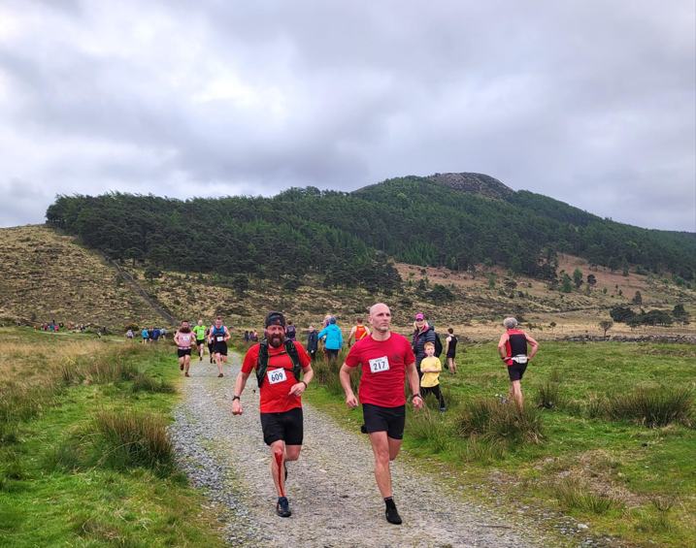
Photo 1- Number 217 Michael Morgan (Newcastle Harbour & Herron Gutters AC)

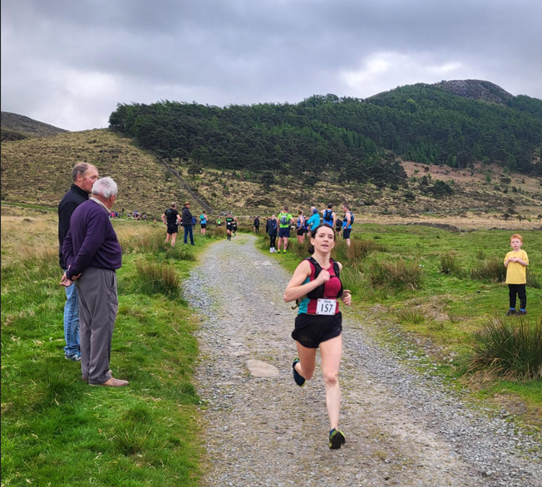
Photo 2- Number 157 Claire Reid (Victoria Park and Connswater AC)

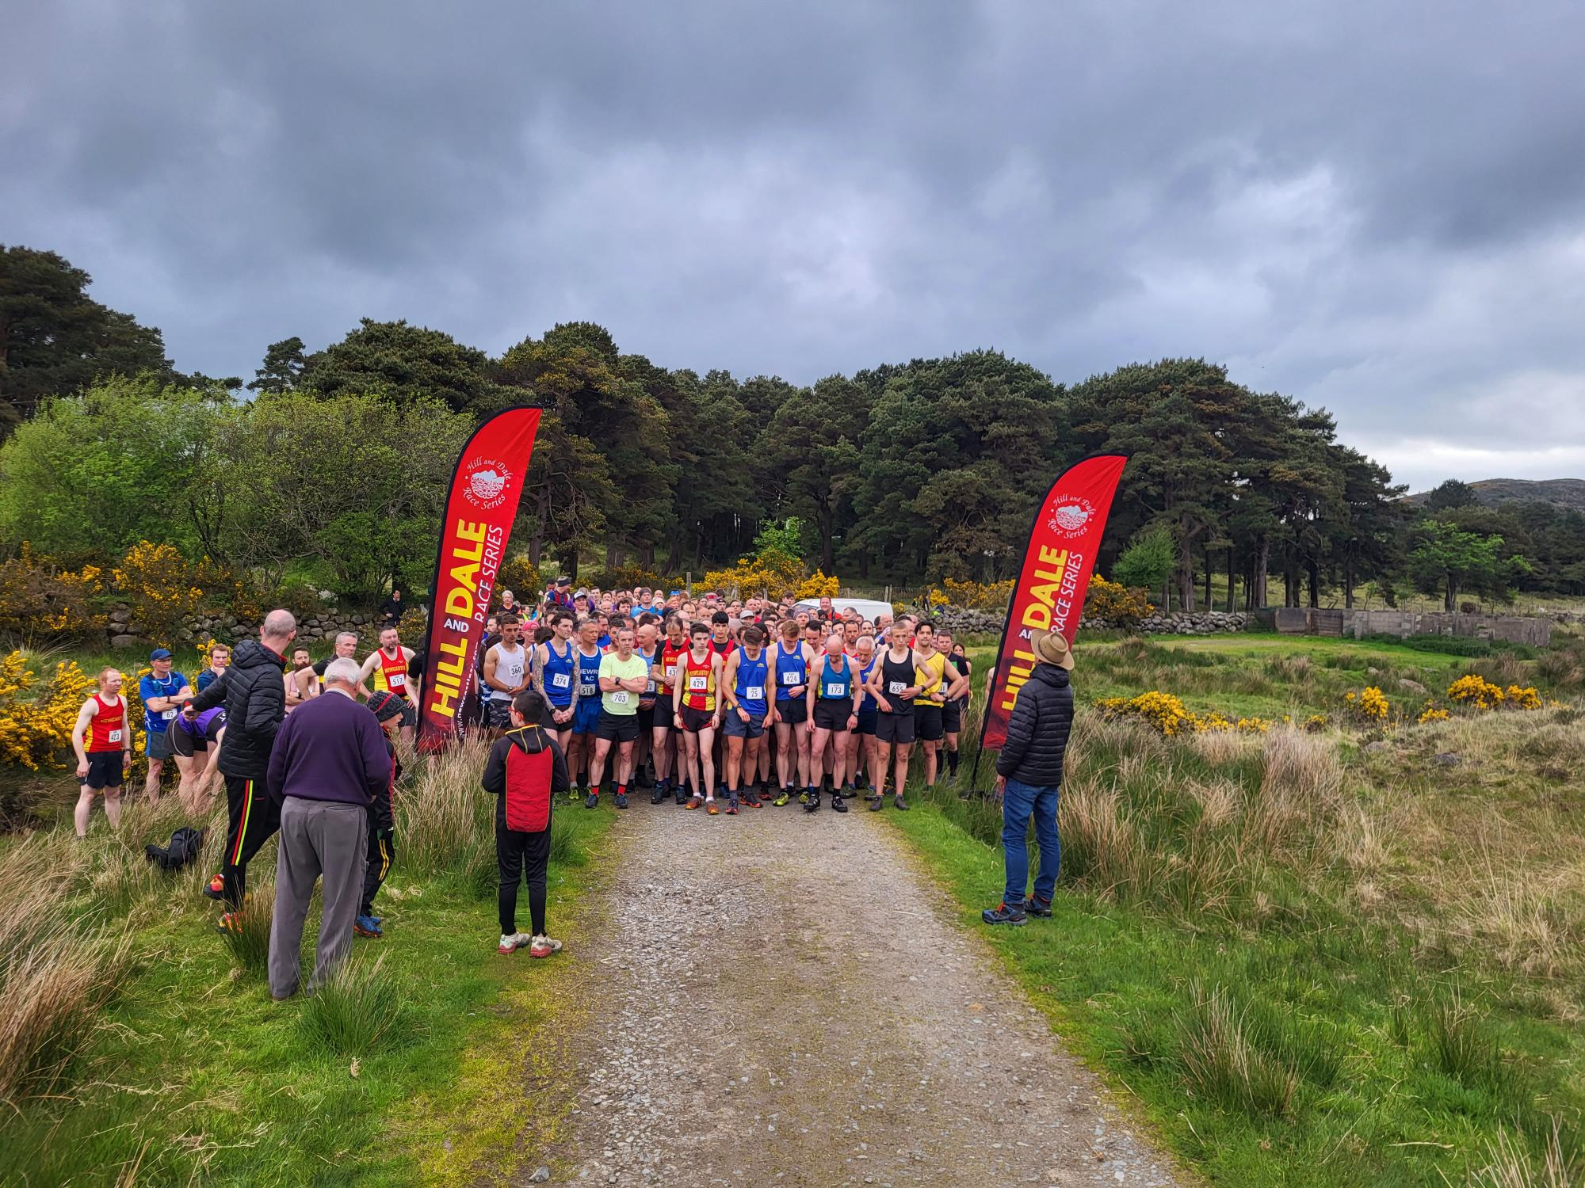
Photo 3- the Shankey’s River start line

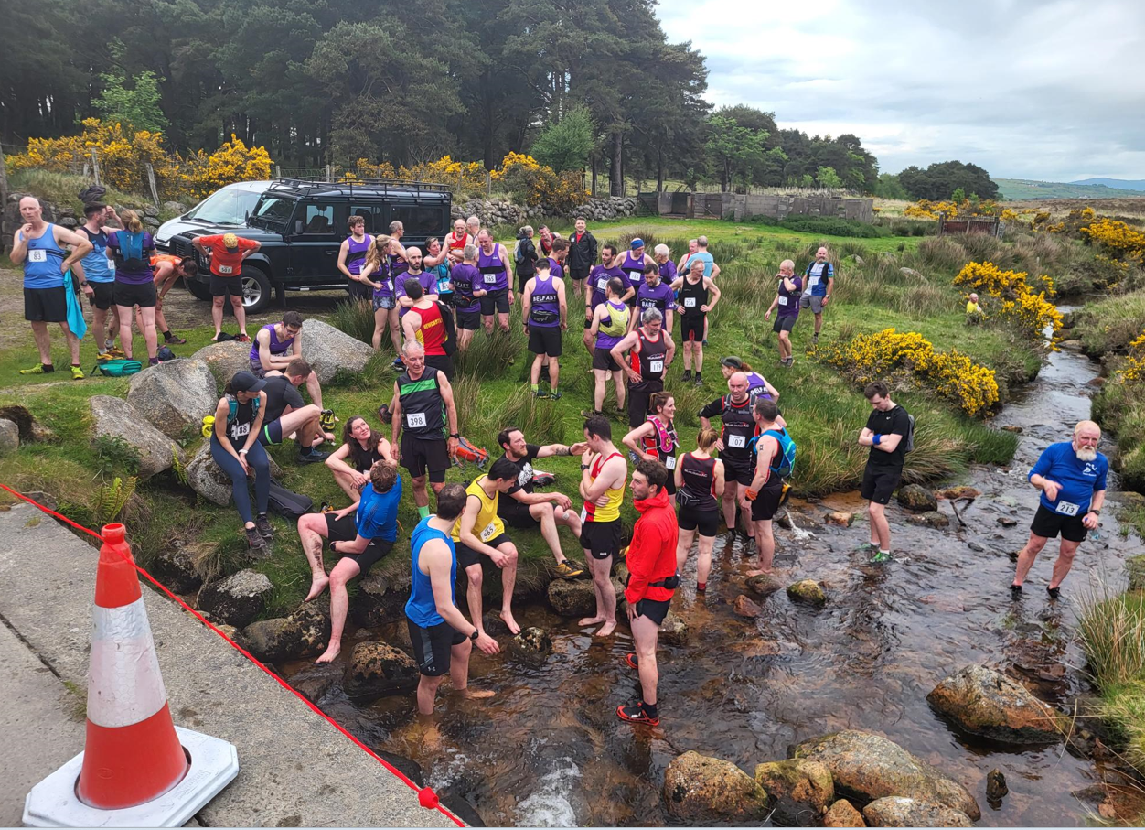
Photo 4- Post race bathing in the Shankey’s River

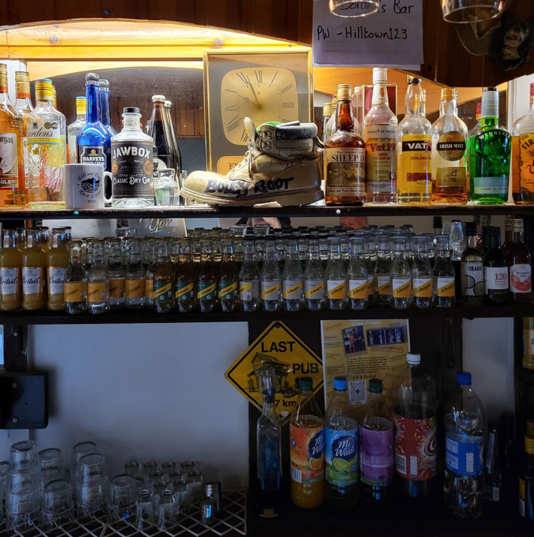
Photo 5- The Doran’s Booley Boot Award

