Midsummer Fun at Luke’s in the Mournes

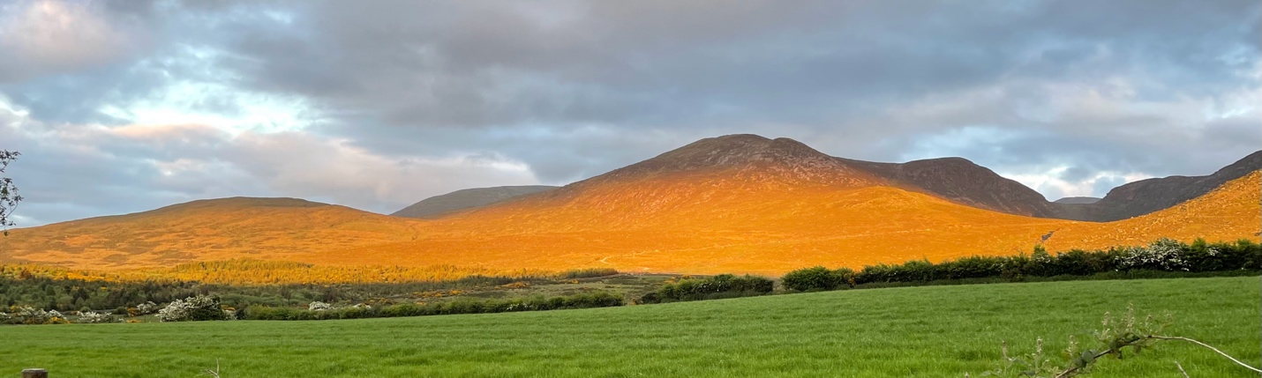
Slievenaglogh centre stage with the lower Luke’s summit to the left

What takes over 200 runners to the Mournes every Thursday night in the spring and early summer? The photograph above taken just after the 206th and final runner crossed the line illustrates part of the reason – the mountains lit up in golden light as the sun drifts towards the horizon to end another day.

Preparations for the 2023 10-race series start back in 2022 and each race has a ‘pair of race directors’ who then pass on the baton and all the rest of the paraphanalia that each race needs to the following race team.

The other main reason is easily understood by just standing close to the finish line and listening as the returning competitors congregate to reflect on how tough the course was, who they might have beaten, the river crossings and the new spring lambs – the happiness in the chatter is palpable.

Father Time
…is not too kind on any of us and the official Hill & Dale senior timekeeper for too many years than he would care to discuss is Frank Morgan. With the weather set fair, he arranged a day out in the Mournes to do some route planning for the 2-Day Mourne Mountain Marathon which comes round in September, with Jim Brown.

“Sure we’ll meet in Donard Car Park in Newcastle in the morning, we’ll spend the day plotting challenging checkpoints and it’ll be handy for me when we get back for the Millstone Hill & Dale race in the evening”. A great plan and after a productive day in the gorgeous summer sunshine, Morgan wondered why there seemed to be no one loitering with intent back at base. Then it struck him, the Millstone race is next week… good old father time was a week early and into the van he jumped and headed for Meelmore Lodge the Race HQ for Luke’s, this week’s Hill & Dale race.

He made it with plenty to spare and trusty watch in hand he signalled the start of the race at 7:29pm and promptly retired for a half-hour nap in the back of his van, for a well-earned rest after an exhausting day and await the return of the hordes.

Talk then turned to fitting out camper vans, the best materials for the job and where to find them and even the G&Ts flowed for the non-drivers among the helper crew with tea for others and buns for all.

The Race
David Smyth established a name for himself at this race last year when he jumped the grass bank to steal a lead onto the lane to the mountain. This year was a greater challenge as a lone camper had parked his car and pitched his tent on the best line out of the start field. Undeterred as Morgan’s start whistle sounded, Smyth sprinted off on a necessary wider line and made the lane, with his customary 10-metre lead like a galloping donkey, with the new-born mountain lambs sprinting for cover at the sight of it.
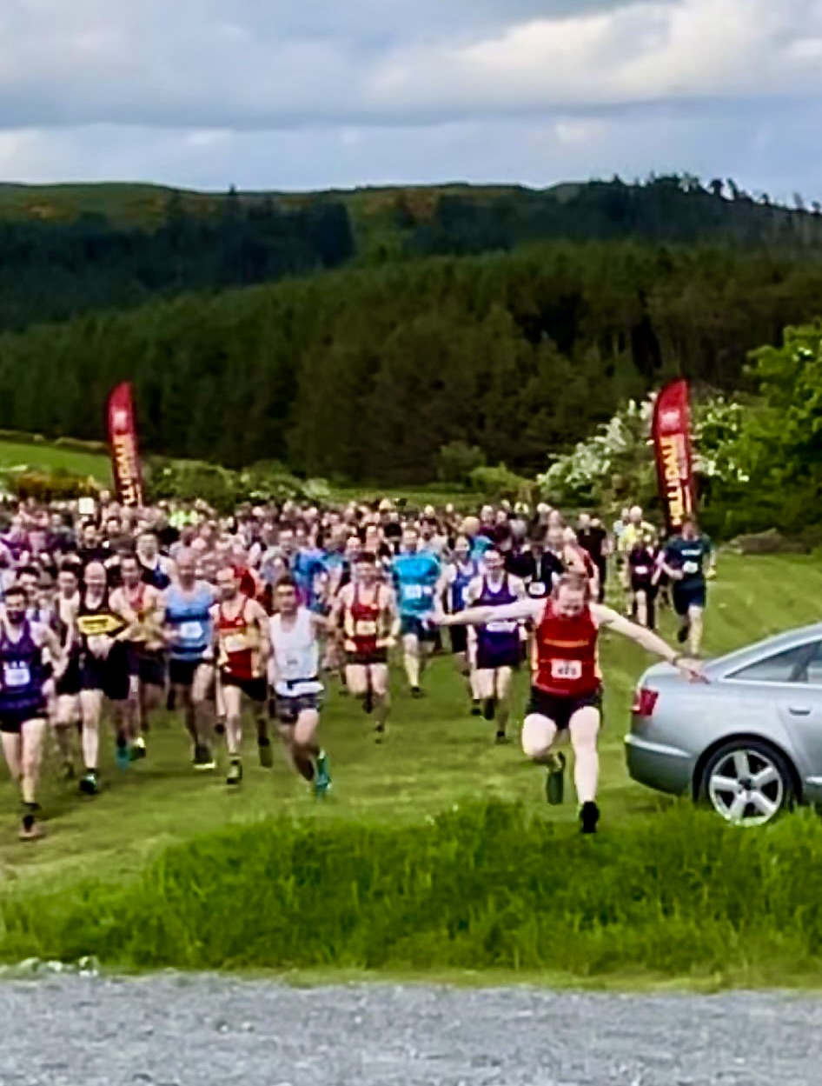
David Smyth springs to an early lead eventually coming home 14th
in 42:50 the identical time to his performance last year

Behind him it was Ballyvea footballer Ashley Crutchley who led from Mourne AC’s Josh McAtee and BARF’s Andrew Tees and as they hit the mountain proper were clawing Smyth back quite quickly.

The Luke’s race is technically challenging with rough terrain and being more across rough tarrain than on established mountain trails. Crossing the Trassey Track the runners try and make as direct a line for the summit of Slievenaglogh and from there is the direct line to Luke’s Mountain and then the choice of route back towards the start.

Martsje Hell of North Belfast Harriers climbed well with race favourite Newry’s Esther Dickson not far behind and knowing that on the rougher descents she would be favourite.
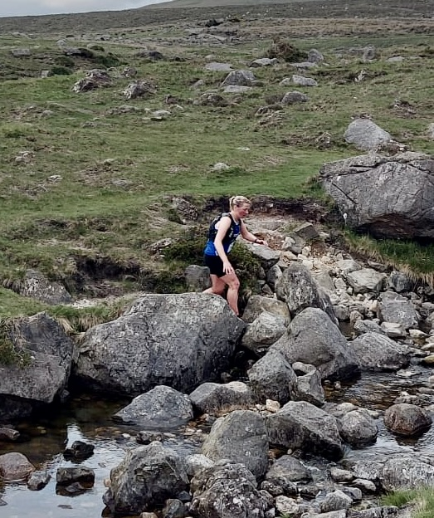
Winning lady Esther Dickson on the final river crossing

And so it was to pass, Dickson came home strongly to win the Women’s race in 45:29 with Hell over a minute behind in 46:47 and Charlene Abraham in 3rd in 47:01.

Meanwhile in the men’s race Crutchley was the first to the summit of Slievenaglogh but hot on his tail were McAtee and Tees and it was the strength of McAtee which prevailed in the end coming home to win in 38:15 for his first victory in the series and 2 places better than his 3rd place last year. Tees has been a winner this year but had to accept 2nd place 20 seconds behind the winner in 38:35. Crutchley was third in 39:10.

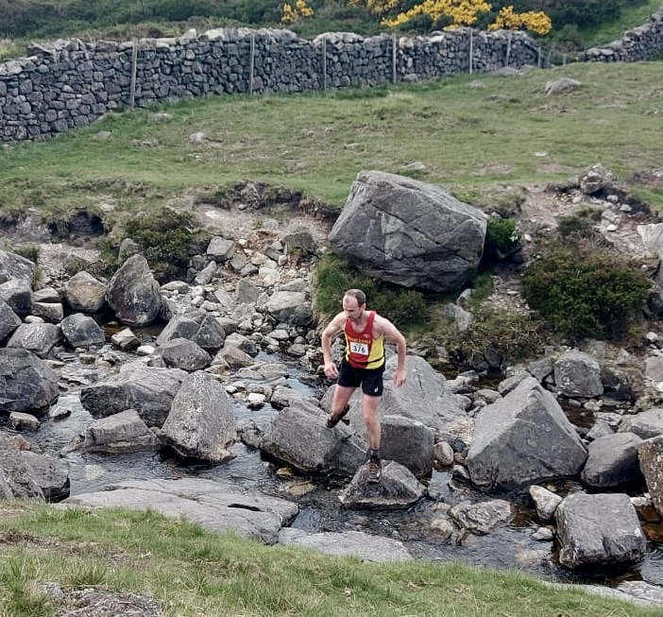
Gary McEvoy on the final river crossing eventualy placing 10th in 41:59

Thankfully for all the rough ground that the runners transversed there was only one DNF out of the 207 starters, a damaged ankles could be spotted among the finishers and the first aid kit was called on to tend to cut knees and scratches. The biggest threat to the murmuring crowd growing at the finish line were the gathering hordes of midges attacking any uncovered flesh – only one side winning here.

Thanks are due all the helpers including the registration and finish line scanners (Debbie, Lorna & Kerry), to Mark Hanna and Ian McCracken for their efforts on the summit of Slievenaglogh, the Prophet, Ethan and Rory for the summit of Luke’s, for … at the mountain gate and … directing the runners off the lane and into the finish. Honourable mention to for Hen Kelly on returning a box of the 2023 Series Memorial Mugs.

Thanks to the Avoca for the after race festivities where the demand for mugs remains strong. Next week is race 7 of 10 over Millstone, where the baton is handed to Audey McVeigh and Pete Grant, full body cover required, from Donard Demesne at the usual time, 7:30 (or even 7:29) sharp where reportedly Father Time is already camped out in the back of his van.

Bogboy & Assistant Jacko

