Fast and Furious Drinnahilly is the fitting finale to a fantastic series.
Hill & Dale Race 10 by Bogusboy

Cometh the last night, cometh the man. Renowned for his meticulous record keeping and the ability to write more than 1000 words on a single post-it note, before showing conservation awareness and doing the same on the reverse, it would seem apposite that Damien Brannigan would be entrusted with the responsibility of organising the final evening of the Hill & Dale Series. Never one to shirk his responsibilities, Brannigan quickly assembled a legion of volunteers to ensure that literally no stone was left unturned - in fact there are rumours that every stone was lifted, washed and returned in preparation for the big night. With military precision, the army of volunteers went to post to ensure that no one could deviate from the carefully crafted plan that everyone would return by 8:20 at the latest - the exact moment when the cous cous would require its second forking and the spicy bean burger, festooned with almonds and cherry tomatoes would need to be put in the oven. The assiette of seasonal vegetables could then be prepped and dinner could be on the table at exactly 8:42 and 29 seconds, thus maintaining his well established and much envied equilibrium.

While Brannigan was ruminating on his forthcoming mastication, the entries team were busy in the corner of O’Hare’s admonishing people for the final time and distributing the series gift for those mad enough to complete 6 of the 10 races. An intricate funnelling system consisting of three chairs was in place and implemented with absolutely no enthusiasm whatsoever. While most come in, exchange a few pleasantries and be on their way, Aine McNeill arrived with a little bag of goodies as a token of her appreciation for the work of the organisers each and every week. The Heroes for the heroes were scoffed with much aplomb by a small minority of the posse who will remain nameless. Who would have known that Olympians had a penchant for a Dinky Decker!

Drinahilly is fast and furious and on most occasions the outcome of the series is already decided and there is a feel akin to the final stage of the Tour De France. Not so this year as the outcome was very much in the balance. Out of the blocks quickly was Niall Goodman, worming his way to the highest point of the course with around 10 seconds to spare over Ashley Crutchley. However on the very sharp descent, Crutchley with a lot of racing under his belt recently proved too quick on the way down. Despite clocking a 5:05 third mile, Goodman had to settle for second place as Crutchley crossed the line first with 12 seconds to spare to claim the overall series victory; something those of us who have been around the Hill & Dale could not have contemplated 2 months ago. Andrew Tees finished third, something he has grown accustomed to in recent days. Joshua McAtee, the other contender for the overall series win finished 6th and can be pleased with his runner up position in the series.
Martsje Hell was first female followed by Katie Graham and Shileen O’Kane.

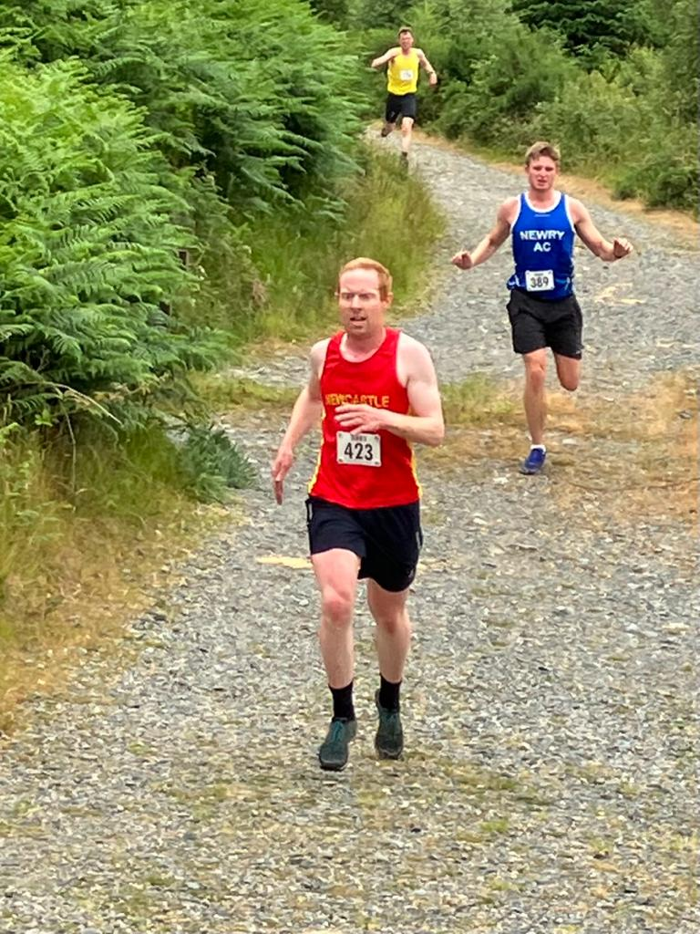
David Smith and Timothy Conway

As the athletes barrelled down the final stretch toward the line there were some gargantuan battles with some pincer movements enabling a place or two to be stolen. Brannigan and McCann had a job of work in controlling the finishers and making sure that Debbie did not end up trampled and the big scanner destroyed. Without the big scanner, there would be no results and organisers left working all weekend to assemble a set based on video footage.

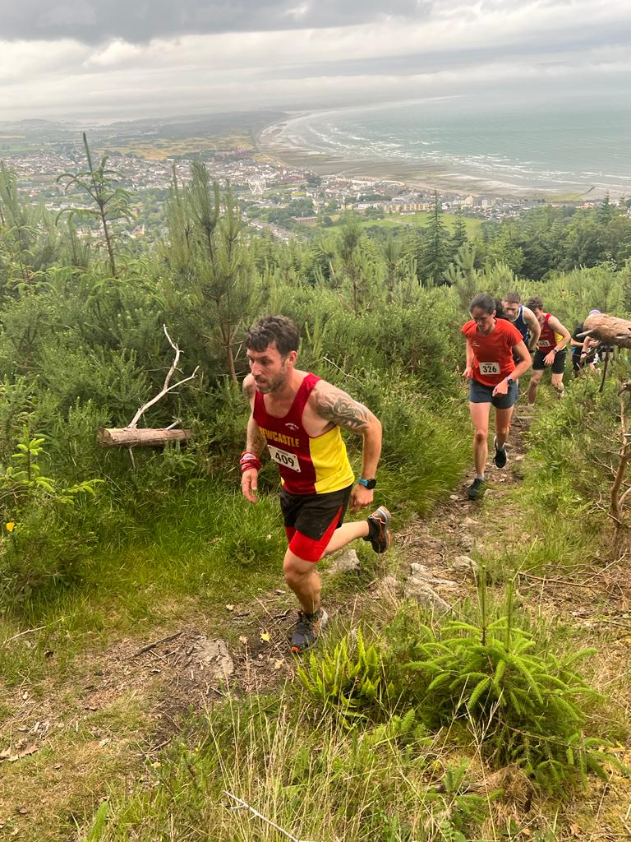
Ryan Carson and Martsje Hell

With everyone home safe, Brannigan set off for a run and everyone else went to O’Hares for liquid hydration and a review of the events of the last 10 weeks, where memories were shared over a sasparilla or two.

As another successful series came to an end, we would like to thank everyone who contributed to the unique atmosphere that characterises each and every race. For the most part, we have been blessed with glorious evenings, notwithstanding the night of Binnian, and this has made life more bearable for the marshals atop the various hills. There has been a great team effort from NAC members, family and friends to deliver a uniquely wonderful acing experience for almost three months. Well done to all. We look forward to seeing you all in Spring 2024, when invariably the Hill & Dale will be bigger, stronger and better than ever.

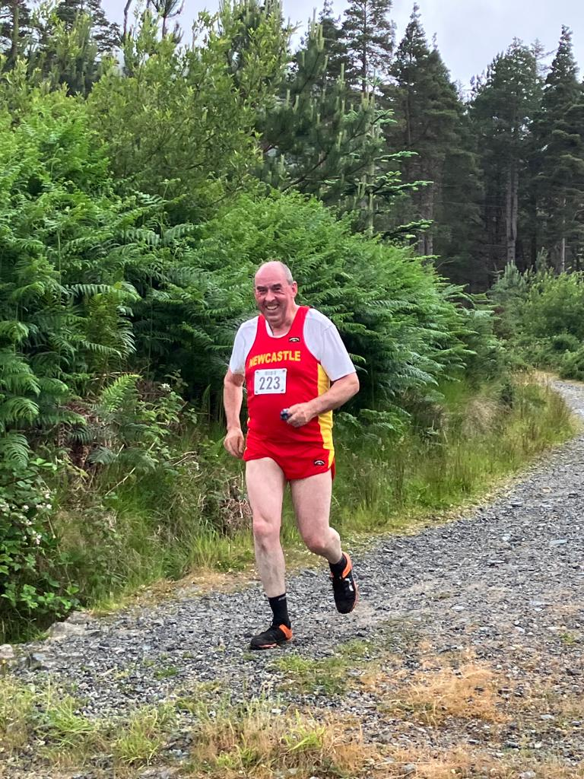
Connell Nugent

