Crutchley & Dickson are 2023 Hill & Dale Champions

For those of you who have seen the written efforts of Bogusboy reporting on the final Hill & Dale race of the series – Drinnahilly – the legend that is Damien Brannigan gets a lot of attention… Bogusboy neglected to mention the mighty efforts of his daughter Chloe in the smooth running of the race. Granted, at one point, her attention was more on protecting her aunty Olivia’s canine friend who recently celebrated turning 50 (Olivia not the dog) from other fearsome wildlife at the finishing line (and that was only the runners) rather than helping her dad. Beware all road users as Chloe now turns her attention on becoming a qualified driver – where do the years go?

Overall Series Results
The overall series results are produced from each runner’s best 6 results from the possible 10 races. After a bout of COVID confined him to barracks in 2022 the Club Chair, Deon McNeilly was in fine form in O’Hare’s Wedding Emporium at the Series Prizegiving. He was ably abetted by the Joe McCann, the man with the witty tongue (allegedly) on the microphone, keeping proceedings lively and perhaps entertaining.

Clubs from far and wide were well-represented to feast on delights from the kitchen and the odd Guinness or two or indeed whatever took their fancy – Ballymena Runners, Armagh, Newry AC, East Down, North Belfast, Blayney Rockets, Lagan Valley, Jog Lisburn, Murlough, Springwell, Dromore, Ballydrain, North Down, Victoria Park & Connswater, Jog Moira, BARF, Mourne Runners, Willowfield, Banbridge, Orangegrove, East Antrim, QUB, Seapark, Dub, Saintfield, East Coast and the host club Newcastle & District were all represented in the runners who completed 6 races in the series.

Massvie congratulations to Newry AC’s Esther Dickson took the overall women’s title for the 5th year in a row (2017, 2018, 2019, COVID years gap, 2022 & now 2023). Last year it was a closely fought battle with Dromore AC’s Diane Wilson and this year it was North Belfast’s Martsje Hell who took 3 victories and 3 second places for 9 points to finish 2 points behind Dickson on 7 points (5 victories and 1 second place). Dickson also secured the FV35 category ahead of Hell.

Wilson, finished in 3rd place on 19 points which included two 2nd places (at Millstone and the Meels) and also easily took the FV50 title.

The men’s title went down to the wire with Mourne’s Joshua McAtee leading going into the final race on 11 points (two 1st places, three 2nd places and one 3rd place), ahead of Ashley Crutchley, who only took to running recently to ‘get fit for football’ who came into the race on 12 points (two 1st places, two 2nd places and two 3rd places). Crutchley knew that only victory would be good enough and McAtee knew that on countback 2nd place wouldn’t be enough. So the scene was set and a brilliantly competitive race to the title was settled whenever Crutchley caught and passed Niall Goodman on the firebreak descent off the TV Mast in Donard Forest and kept the lead all the way to the finish.

So congratulations to 19-year-old Crutchley on gaining the Series title on 10 points ahead of McAtee on 11 points. It’s so brilliant to see the youth coming through with Tom Crudgington winning at 17 last year and Ashley only 19 winning this year.

In third pace overall was Andrew Tees from BARF on 16 points after two 2nd places and 4 3rd places.

Overall the series was the most well-attended ever with many more experiencing the escapism from ‘normal life’ on a Thursday night racing in stunning scenery where every race is different. 74 women and and 177 men, making 251 runners in total completing the 6 races required – a record by a long way. Indeed 21 runners completed all 10 races and congratulations to them.

Age Category Winners
John Adgey of North Down has been racing on the mountains for what must be close to 50 years now and he is a Hill & Dale perennial. It is so brilliant to see him race 8 races this year out of 10 and secure victory in the MV75 category over BARF’s Ian Taylor.

We used to call him ‘pipe-smoking’ Peter McGuckin but the pipe has not been in evidence for a while now. McGuckin dominated the MV70 category ahead of Mourne Runners’ Ricky Cowan.

Congratulations to Mary Mackin from Dromore AC on securing the FV65 title with the perfect 6 points for the second year in a row. Her counterpart in the MV65 category was Dominic McGreevy who continued his series domination in the age groups from recent years and with the perfect score of 6.

Murlough’s Pat Shields retained the FV60 title with another perfect score and turned up to pick up her winners’ cup. The scribe here can only apologise to her for his stupidity. Pat had diligently returned her trophy at registration for in Tollymore at the second race of the series and due to a lack of diligence the trophy didn’t make it to the presentation. It will now be engraved before providing to the rightful owner who all being well will look to secure again in 2024.

Newry’s Paul Le Blanc has been a regular competitor in the Hill & Dales and this year he was up against BARF’s Jim Brown, a previous age category winner. With 5 wins and a 3rd place, Le Blanc took the MV60 title over Brown’s 1 win and five 2nd places.

The women’s FV55 title went down to the last race with Dromore’s Aine McNeill, who had led over the first 9 races, being pipped at the post by Lagan Valley’s Shileen O’Kane racing to her 6th and crucial victory in Drinnahilly.

Congratulations also to Stephen Hoey of Jog Lisburn who won the first two races of the series at MV55 level, returned to win on the tough night at Binnian and at the next race over Rocky. He then won at Millstone and took the final race at Drinnahilly to score the perfect 6.
I earlier mentioned Diane Wilson who took 3rd place overall in the series and secured the FV50 title over Amanda Perry who came to Drinnahilly to secure 2nd place ahead of Karen Wilton in a very competitive category. The MV50 category was secured by Newry’s Warren Cartmill ahead of BARF’s Declan McGrellis.

Newry’s Ciara Coffey took the FV45 title 5 victories and a second place with her club mate Maurice Harte taking the men’s MV45 title with 6 victories. Willowfield’s Tanya Cumming took the FV40 title with 6 victories and Andrew Tees winning the MV40 title (alongside his 3rd place in the series overall).

The women’s V35 category was won by overall series winner Esther Dickson while Jog Lisburn’s Marc Jennings took vicory in the final race to secure a perfect score of 6 to win the men’s V35 title.

It was great to see Ciara Savage secure the series female junior title again and having secured a virgin victory at the final race last season, Ethan O’Kane returned for this year’s series to romp to the male junior title. Ethan is the son of FV55 winner Shileen and perennial series competitor Donal – proving that it is in the genes.

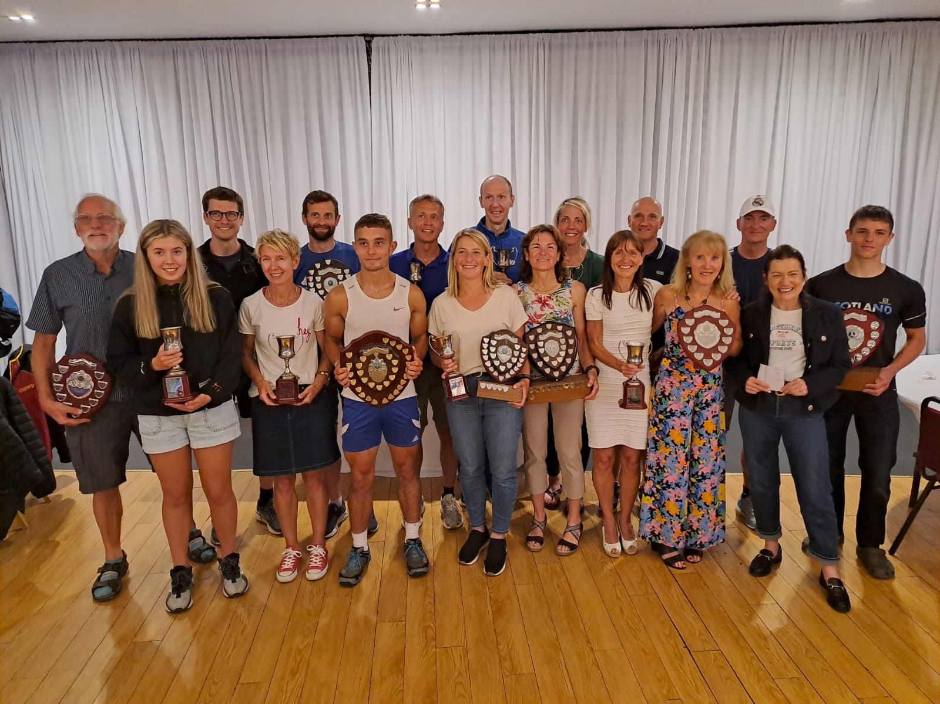
LtoR: John Adgey, Ciara Savage, Marc Jennings, Diane Wilson, Andrew Tees, Ashley Crutchley, Maurice Harte, Esther Dickson, Stephen Hoey, Aine McNeill, Ciara Coffey, Shileen O’Kane, Warren Cartmill, Mary Mackin, Paul Le Blanc, Pat Shields, Ethan O’Kane

Runners’ Runner
Each year this prestigious award is made not to the fastest runner but to the individual – runner or helper- who embraces the spirit of the series. Having broken the spirit of the award by not awarding it last year the organisers made up for it this year by retrospectively awarding for 2022 as well as for 2023 – still with me?

The 2022 winner was Debbie Biggerstaff who is the Chief Scanner, wielding the beast at the finish line with great accuracy and energy. Debbie raced many times in the series years ago and is an almost ever-present (sometimes having to take annual leave from her shiftwork with the Council) at the finish line – a well-deserved award for a vital cog in the chain.

The 2023 winner always turns up with a smile on her face, runs with a smile (except when the pain takes over) and afterwards is always thankful for the opportunity to have raced. Her joy is infectious and brings so much positive energy to every conversation. Congratulations to Dromore AC’s Aine McNeill (who incidentally also finished 2nd in the FV55 category for the overall series).

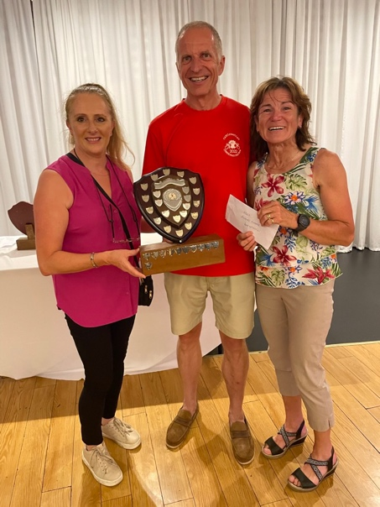
Runners’ Runners for 2022 & 2023 – Debbie Biggerstaff & Aine McNeill with Chair Deon McNeilly

Titanic References
As a footnote to the proceedings, the most experienced professional timekeeper on the circuit, Frank Morgan was spotted in deep conversation across the evening with celebrated artist, Brian Vallely from Armagh – at least that’s how many in the general public know him. However, for us in the running fraternity we also know him as someone who has for at least 60 years been steeped in athletics. After a succesful competitive career he turned his attention to being a race director. He is a driving force behind the world-renowned Armagh International Road Races which take place each February around the Mall which has the greatest strength in depth men’s 5k road race in the world each year.

We know him best for being the organiser of the annual Slieve Gullion and Flagstaff to Carlingford Mountain Races. Anyway Brian is painting as prolifically as ever but on Friday evening his question to Frank was – “who is this Miss World that I read references to – she’s a member of the Newcastle club?” So it was to pass, as Lorcan was encouraging his dad Brian to leave, failing several times, Frank spotted Miss World and once again thwarted Lorcan’s exit attempts. Upon a few words of introduction, in the words of Rose (Kate Winslett) to Jack (Leonardo) from Titianic, Lorna, sorry Miss World, suddenly proclaimed “Brian, draw me like one of your French girls…” Well that worked the trick for Lorcan for within 5 minutes both him and his dad were on the road pointed for Armagh.

Another Hill & Dales Series has slipped by and it is really important to thank everyone who helped across the past 3 months and in putting in the hard yards to prepare for the Series – it is a massive team effort and not only would it be unfair to start to name anyone as there are so many but it is also impossible to list all the roles that need to be filled – a massive thanks to everyone who helped in any way at all. Enjoy summer and stay safe.

Until next year…

BOGBOY – the original and the best

